
PROJECT INFORMATION

Project Name : Urban Thrift
Theme: THRIFT FASHION STORE
Category: Responsive NEXTGEN Website

TEAM INFORMATION
TEAM NAME: PIXEL CRAFT
MEMBERS
ID NUMBER | BATCH NO. | STUDENT NAME
1730363 | AI-202603E | RANA MUNEEB
1730435 | AI-202605B | MAAZ AHMED
1731527 | AI-202605B | ASHER JAMIL
1731004 | AI-202605B | HUSSAIN MUAVIA
1730099 | AI-202603E | UROOJ ASHFAQ
ACKNOWLEDGE

I would like to express my sincere gratitude to my teachers, supervisors, and everyone who provided guidance and support throughout the development of the Thrift Fashion project.

I am thankful for the opportunity to work on a real-world web development project that allowed me to improve my skills in user interface design, responsive web development, JavaScript programming, data handling, and project documentation.

PROJECT SYNOPSIS

Thrift Fashion is a responsive Single Page Application designed as an online fashion store. The website allows users to browse and explore different fashion products such as clothes, watches, bags, shoes, and other accessories.

The main purpose of the website is to provide users with a simple, attractive, interactive, and responsive shopping experience.

The application contains product browsing, category filtering, shopping/cart functionality, checkout calculation, contact functionality, visitor count, date/time/location ticker.

PROBLEM DEFINITION

Many people want to buy stylish and good-quality clothes at affordable prices, but new fashion items can be expensive. At the same time, many usable clothes are discarded, creating unnecessary waste.
The Thrift Fashion Store project aims to provide an easy online platform where customers can find affordable clothing while promoting sustainable fashion, reuse, and waste reduction. The website will make it simple for users to browse products, view details, and purchase their favorite items.

OBJECTIVES

- To develop a responsive fashion e-commerce website.
- To create an attractive custom user interface.
- To provide product browsing functionality.
- To attracting customer.
- To develop a responsive fashion e-commerce website.
- To create an attractive custom user interface.
- To provide product browsing functionality.

BACKGROUND AND NEED

Fashion is one of the largest and continuously growing online shopping categories.A fashion website needs to be visually attractive because product presentation strongly affects the user's shopping experience.

- Attractive product presentation.
- Easy product discovery.
- Convenient online browsing.
- Mobile-friendly shopping.

PROPOSED SOLUTION

- HOME PAGE
- NAVIDATION BAR
- HERO/MAIN SECTION
- PRODUCTS SECTION
- PRODUCT PAGE
- PRODUCT LIST
- COLLECTION PAGE
- ABOUT PAGE
- CONTACT PAGE
- FEED BACK PAGE
- RESPONSIVE NAVIGATION BAR
- FASHION PRODUCT CATALOG
- CLOTHES CATEGORY
- WATCHES CATEGORY
- SHOES CATEGORY
- ACCESSORIES CATEGORY
- QUANTITY MANAGEMENT
- REPONSIVE DESIGN
- INTERACTIVE UI

SCOPE
The scope of the Urban Thrift Fashion Store project includes developing a responsive and user-friendly website for buying and exploring fashion products.
The project will include:
- Displaying thrift clothing and fashion collections.
- Product details, images, prices, and categories.
- Search and shopping cart functionality.
- Home, Shop, Collections, About Us, Contact, and Feedback pages.
- Responsive design for desktop, tablet, and mobile devices.
- Product data stored and displayed using JSON.
- Interactive features using JavaScript.
- Promoting affordable and sustainable fashion.
Future Scope:
The website can later be expanded with online payment, user accounts, order tracking, product reviews, and an admin panel for managing products and orders.

CONSTRAINTS

- The website is developed using only HTML, CSS, and JavaScript.
- Product information is stored using JSON data.
- The project does not include a real online payment system.
- No advanced back-end or database is included.
- Product availability is limited to the data added by the website administrator.
- Internet access may be required for external images or icons.
- The project has limited time and resources for development and testing.
- Advanced features such as live order tracking and real-time inventory management are not included.

PROJECT ANALYSIS

The Urban Thrift Fashion Store project is a responsive e-commerce website designed to make thrift shopping simple, affordable, and attractive. The website provides users with an organized platform to explore pre-owned clothing and fashion collections.
The system analyzes user needs such as easy navigation, affordable products, attractive design, product information, and convenient shopping. Products are displayed using JSON data and dynamically presented through JavaScript.
The project focuses on creating a modern, user-friendly, and sustainable fashion platform using HTML, CSS, and JavaScript. Its responsive design allows users to access the website comfortably on different screen sizes.
Overall, the project aims to combine fashion, affordability, sustainability, and a smooth user experience in one online platform.

UI DESIGN SPECIFICTIONS

UI Element | Specification
Specification | Thrift Fashion / E-commerce Store
Theme | Modern, minimal, sustainable, premium
Primary Colors | Dark charcoal/black, cream, light beige, olive/golden accent
Typography | Bold sans-serif headings with clean, readable body text
Header | Top announcement bar + navigation bar
Navigation | Home, Shop, Collections, About Us, Contact, Feedback
Icons | Search, User Account, Shopping Cart,Heart,Recycle,Phone,Copy right,  Map-pin,Truck,Tree,Arrows.
Hero Section | Large promotional banner with clothing-store image and CTA buttons
CTA Buttons | “Shop Now” and “Explore Collections”
Product Design | Clean product cards with image, name, price, and shopping option
Cards | Rounded corners with subtle borders/shadows
Images | High-quality fashion and thrift-store images
Spacing | Generous padding and consistent margins
Layout | Flexbox/Grid-based responsive layout
Responsiveness | Mobile, tablet, and desktop compatible
User Experience | Simple navigation, clear buttons, fast access to products
Overall Style | Elegant + youthful + eco-friendly

Flowchart

Home Page

Feedback
Contact
About Us
Collections
Shop

Sitemap

HOME

OUR SERVICES
BOTTOMS
DENIM
SHIRTS
JACKETS
SHIRTS
PANTS
JACKETS
FOOTWEAR
WATCHES
SHOP
FEEDBACK
CONTACT
ABOUT US
COLLECTIONS

JSON Structure

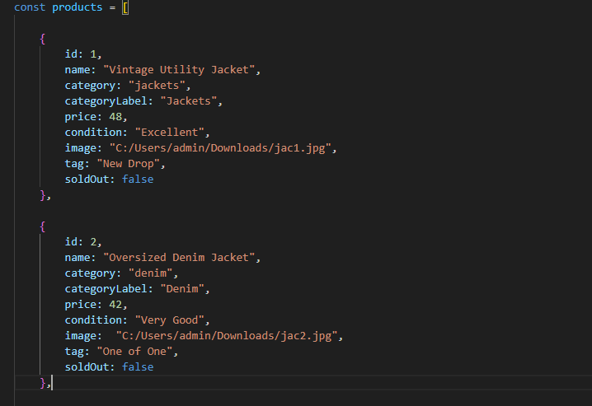

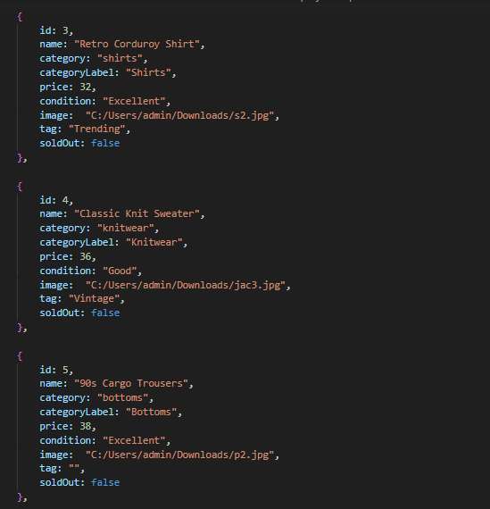

Screenshots

      - Home
      - Shop
      - Collections
      - About Us
      - Contact
      - Feedback
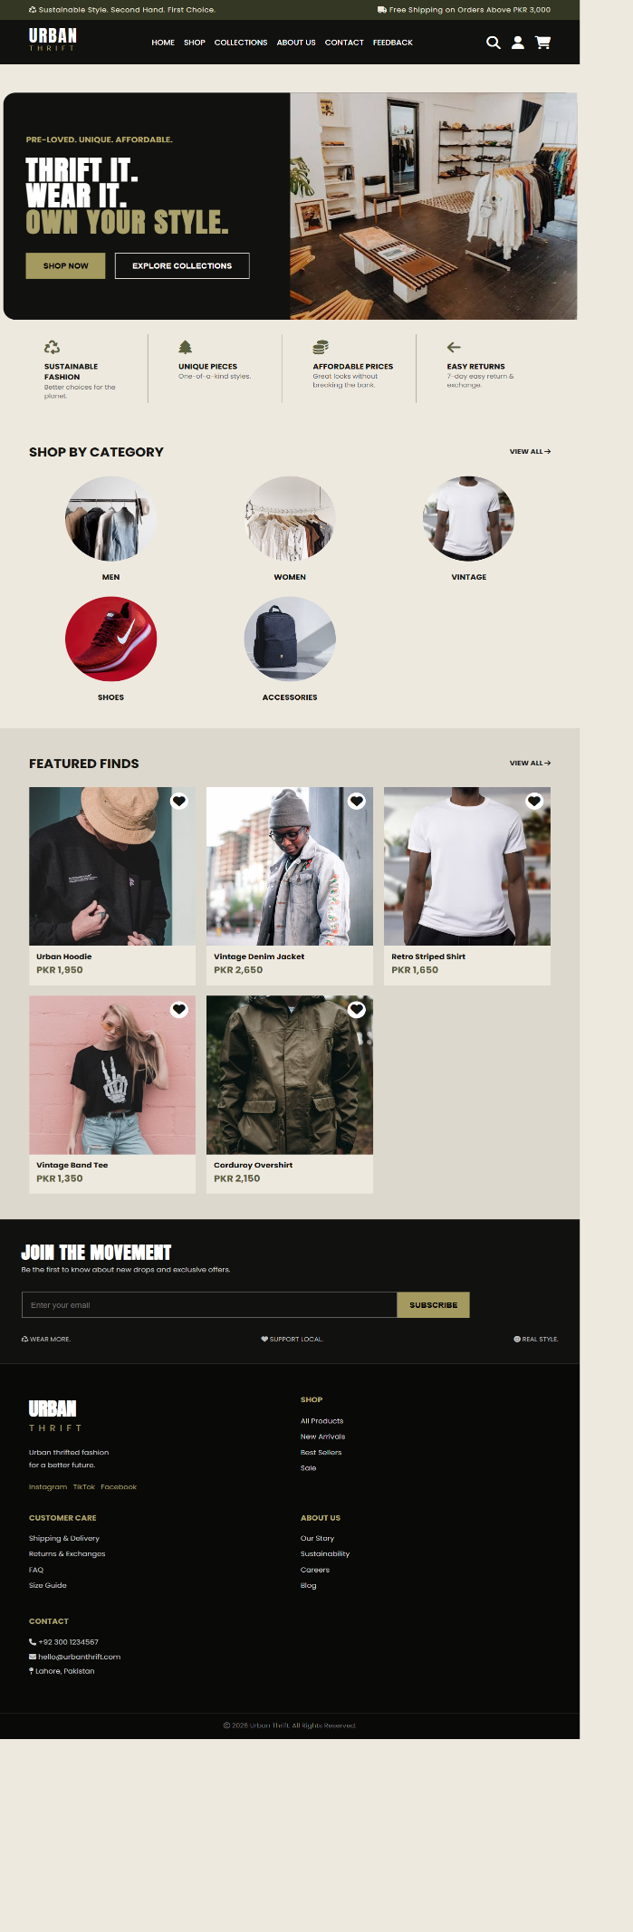
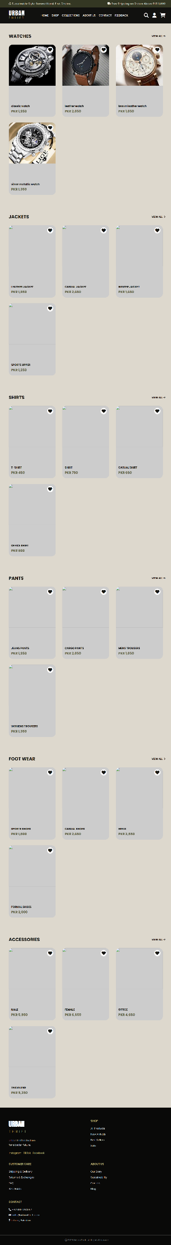
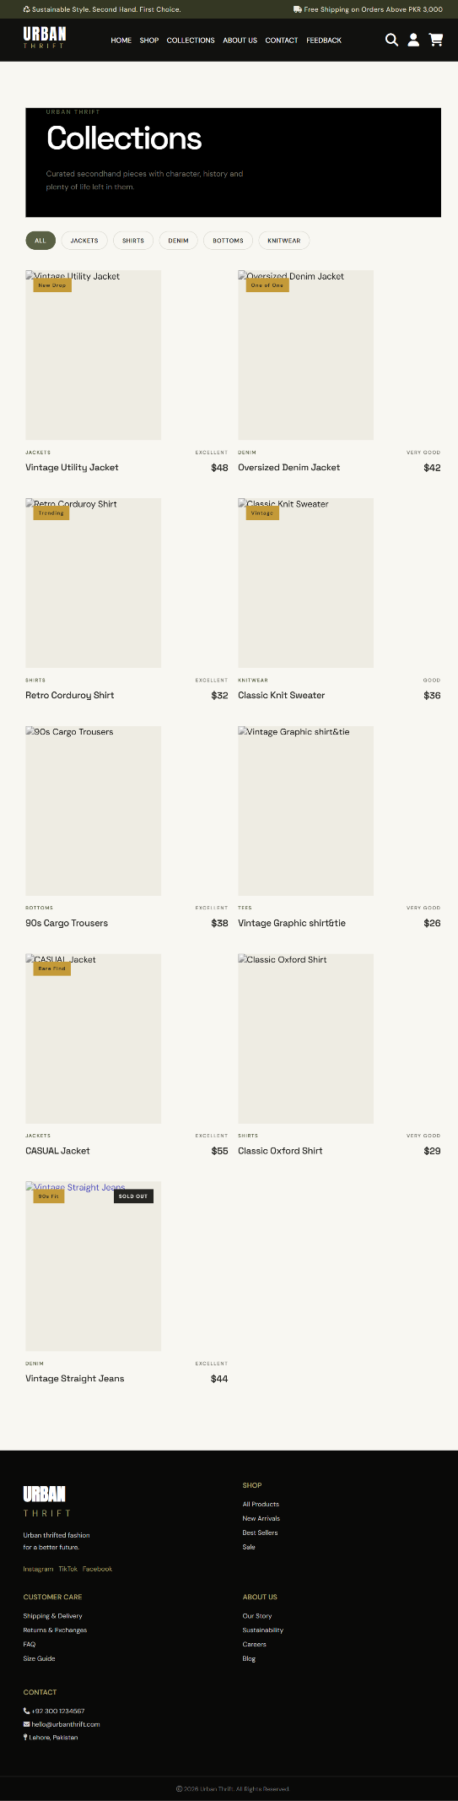

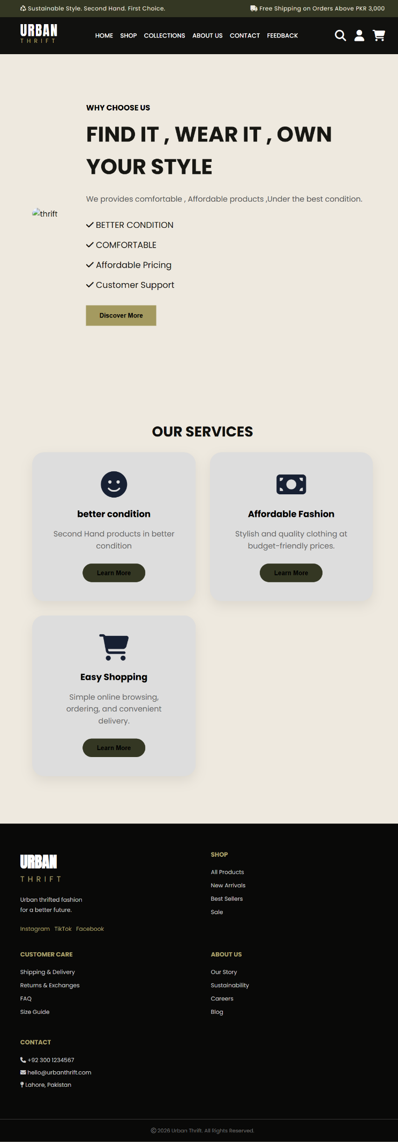
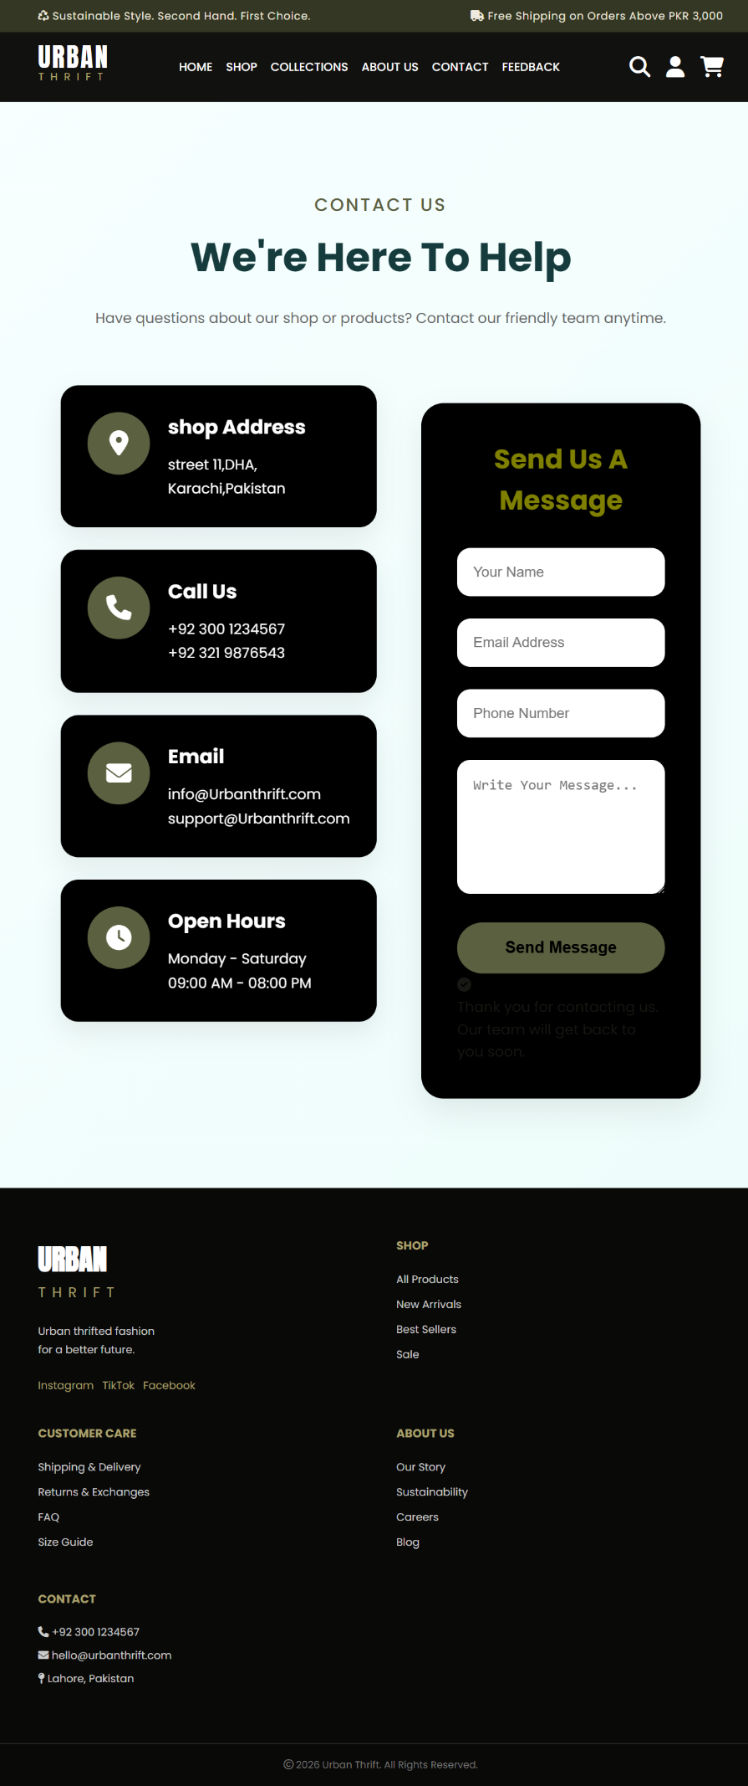

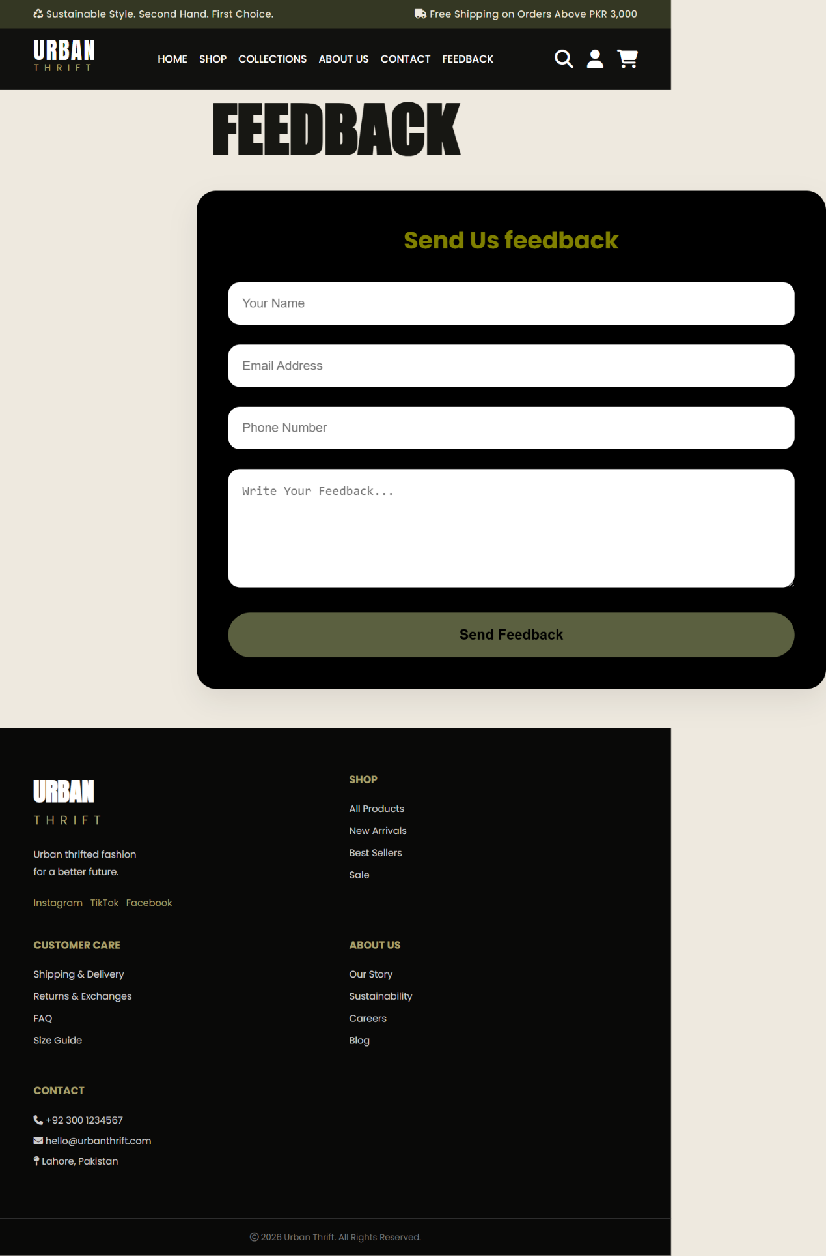

Functional Requirements

- Home Page: It displays menus such as Products, About Us, Contact Us, Feedback, and so on. A few featured products displayed with images and captions are displayed on the home page. The home page accepts first name from the user and display a personalized welcome message. At the top corner, the user's first name is displayed for the entire duration that the portal is loaded.

- Products: This option showcases the products one can order online via Thrift Fashion Store. Products are displayed through an image gallery and can have product information such as availability, stock, price, discount, product description, and so on.

- About Us and Contact Us: This menu option displays Email id, address, and contact number of the organization developing the system. This acts like the Customer Care service, which is available 24/7 to the users in case of any query.

Non-functional Requirements

- Safe to use: The system does not result in any malicious downloads or unnecessary file downloads.
- Accessible: The system has clear and legible fonts, user-interface elements, and navigation elements.
- User-friendly: The system is easy to navigate with clear products/items and other elements and easy to understand.
- Operability: The system operates in a reliably efficient manner.
- Performance: The system demonstrates high value of performance through speed and throughput. In simple terms, the system is fast to load and page redirection is smooth.
- Capacity: The system supports large number of users.
- Availability: The system is available 24/7 with minimum down time.
- Compatibility: The system should is compatible with latest browsers.

